Form of Specifications of Lamps

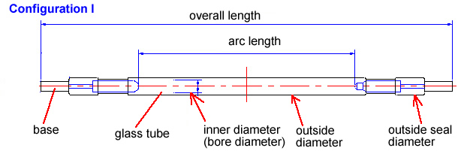

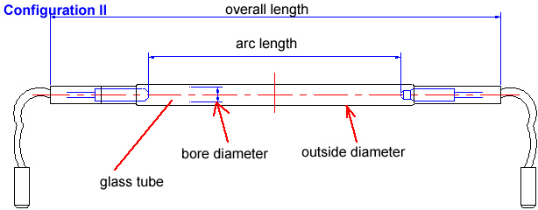

 | Required | Remark
Operation mode & configuration
CW or pulse
Configuration I or Configuration II
Mechanical
Filled gas (Kr or Xe or mixed)
Filled gas pressure (torr) |  | If you do not know the pressure, please tell us your application (IPL, medical use, CW or pulsed laser etc)
Glass tube: bore diameter (mm)
Glass tube: outside diameter (mm)
Arc length (mm)
Overall length (mm)
Base: diameter (mm)
Base: length (mm)
Wire (cable) length (mm)
UV filtering (needed or not)
Electrical
Max. voltage (V)
Max. current (A)
Max. power (W)
Trigger voltage (V)
Quantity (pcs)
Do you design your system now or just look for replacement of the existing lamp?
Additional information such as application area such as CW laser, pulsed laser, IPL, medical use.

If the buyer does not know the above parameters, please provide following parameters:

 | Specification | Remark
Manufacturer of machine
Model of machine
CW or pulse
Laser power
Others

Customer’s Information:
Contact person
Company name
Address
Telephone
Fax
E-mail
Website

In order for us to easily recognise what you wanted, please attach the photos of the used lamp and its box here.

