Form to Order Custom-made Pump Chamber

Company name |  |  |  | Contact person
Phone |  | Fax |  | Email
Product name |  |  |  | Quantity
Required delivery date |  | Remark

Parameters
Chamber dimension | Beam height H |  |  | Chamber height H2 |  |  | Chamber width W |  | Chamber length L |  |  | Reflector length L3
Lamp model or maker |  |  |  |  |  |  |  |  | Base connector
Lamp dimension | OVL |  | L |  |  | L2 |  | L3 | φ1 | φ2 | Base diameter |  |  |  | Base length
Water connector
Bottom plate | (SS, plastic etc) |  |  |  |  |  |  | YAG rod dimension |  | （diamter x length）
Bottom plate dimension | W |  |  |  | L |  |  |  | C1 |  |  |  | C2
Others:

We can make the pump chamber according to your specific requirements. 1) If you are using a pump chamber, please tell us the dimensions or send us a used chamber; 2) if you are choosing a pump chamber, please tell us the dimensions of your lamp and YAG rod; 3) if you are choosing a pump chamber, a lamp and a YAG rod, please tell us the requirements on laser power, laser beam diameter and pulse or CW modes and we will finish all others to make a chamber for you.

We guarantee our chamber! We believe that your laser must be high-quality if you use our chambers!

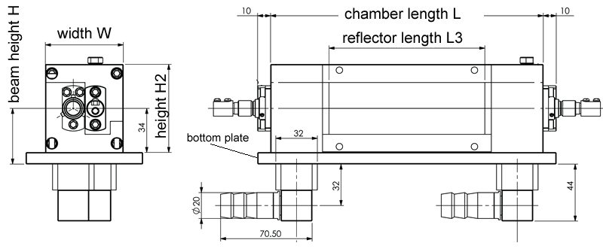

Bottom plate dimension:
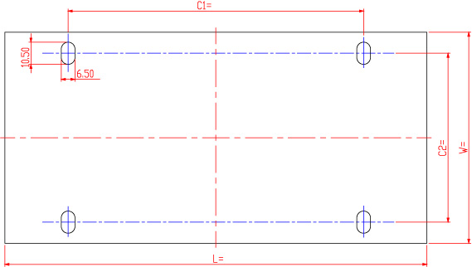

Lamp dimension:
